“IOT Based Smart Agriculture Monitoring System”
A PROJECT REPORT
Submitted in partial fulfilment for the award of the degree of
BACHELOR OF ENGINEERING
Submitted to
SAVITRIBAI PHULE PUNE UNIVERSITY, PUNE
Submitted By
- Aage Jay Chandrakant (TB01)
- Bhoite Sanjay Karan (TB06)
- Dhoke Atharv Vijay (TB11)

Under the Guidance of
Prof. S D Shipne

DEPARTMENT OF ELECTRONICS & TELECOMMUNICATION
JSPM’s IMPERIAL COLLEGE OF ENGINEERING & RESEARCH
WAGHOLI, PUNE- 412207
2024 – 25

JSPM’s Imperial College of Engineering & Research,
Wagholi Pune – 412207

CERTIFICATE
This is to certify that the project report entitled “IOT based smart agriculture monitoring system “ submitted by Jay Aage, Karan Bhoite, Atharv Dhoke is a record of the bonafide work carried out by him / her, under my guidance, and it is approved for the partial fulfilment of requirement of Savitribai Phule Pune University for the award of the degree Bachelor of Engineering (Electronics & Telecommunication).

Prof. S D Shipne Dr. S.L. Lahudkar Dr. R. S. Deshpande
Guide Head of Department Principal
Department of E&Tc Department of E&Tc I.C.O.E.R, Pune

(External Examiner)
Place: Pune
Date:

ACKNOWLEDGEMENT
We are taking efforts in this project. However, it will not be possible without the kind support and help of many individuals and organisations. We would like to extend our sincere thanks to all of them.
We are highly indebted to (Prof. S D Shipne) for their guidance and constant supervision as well as for providing necessary information regarding the project & also for their support in completing the project.
We would like to express my gratitude towards my parents & members of ICOER Staff for their kind cooperation and encouragement which helped us in completion of this project. Our thanks and appreciations to our colleagues in developing the project and to people who have willingly helped us out with their abilities.

ABSTRACT

The Internet of Things (IoT)-based Smart Agriculture Monitoring System is an innovative solution designed to enhance agricultural practices by leveraging advanced sensor networks and real-time data analytics. The system integrates IoT devices, such as soil moisture sensors, temperature and humidity detectors, and light sensors, to continuously monitor the key environmental factors that influence crop growth. This data is transmitted wirelessly to a cloud-based platform, where it is processed and analyzed to provide actionable insights for farmers. Through a user-friendly interface, farmers can access real-time updates, receive notifications, and make data-driven decisions to optimize irrigation, fertilization, and overall crop management. By reducing water wastage, improving crop yield, and minimizing the need for manual intervention, this IoT-based system promotes sustainable and efficient farming practices. The integration of IoT in agriculture holds the potential to revolutionize the industry by providing a scalable solution for smart, data-centric farming that can be adapted to varying environmental conditions and crop types.

CONTENTS

 |  |  | Acknowledgement | i
 |  |  | Abstract | ii
 |  |  | List of Tables | iii
 |  |  | List of Figures | iv
 |  |  | Abbreviations | v
Chapter |  |  | Contents | Page No.
1 |  |  | Introduction | 11
 | 1.1 |  | Motivation | 12
 | 1.2 |  | Problem Statement | 12
 | 1.3 |  | Objective | 12
2 |  |  | Literature Survey
 | 2.1 |  | Literature Survey Table | 14
 | 2.2 |  | Summary of Literature Survey | 16
3 |  |  | Methodology | 18
 | 3.1 |  | Project Outline | 18
 | 3.2 |  | Block Diagram Explanation | 19
4 |  |  | System Specifications
 | 4.1 |  | Hardware Details
 |  | 4.1.1 | NodeMCU | 21
 |  | 4.1.2 | DHT 11 sensor | 22
 |  | 4.1.3 | Soil moisturise sensor | 23
 |  | 4.1.4 | Relay module | 24
 | 4.2 |  | Software Details
5 |  |  | Flow Chart
 |  | 5.1 | Circuit diagram | 26
6 |  |  | Algorithm | 28
7 |  |  | Result | 31
8 |  |  | Advantages | 35
9 |  |  | Conclusion | 37
 |  |  | References | 38

LIST OF TABLES
Table | Title | Page No.
Table 2.1 | Literature Review | 14

LIST OF FIGURES

Figure | Title | Page No.
Fig 3.2.1 | Block Diagram | 18
Fig 4.1.1 | Node MCU (ESP32) | 21
Fig 4.1.2 | Temperature sensor | 22
Fig 4.1.3 | Moisture sensor | 23
Fig 4.1.4 | Relay Module | 23
Fig 5.1 | Circuit diagram | 25
Fig 7.1 | Final model of IOT Based smart Agriculture system | 31
Fig 7.2 | Notification on mobile phone | 32
Fig7.3 | Condition of soil on Blynk app | 33

ABBREVIATIONS

LCD | Liquid Crystal Display
MCU | Microcontroller Unit

CHAPTER 1
INTRODUCTION

Chapter 1
Introduction

Agriculture plays a vital role in the global economy and food security, yet it faces numerous challenges such as climate change, water scarcity, and the increasing demand for food production. Traditional farming methods are often inefficient, labor-intensive, and heavily reliant on manual interventions. In response to these challenges, the concept of Smart Agriculture, powered by the Internet of Things (IoT), has emerged as a transformative solution. The IoT-based Smart Agriculture Monitoring System is designed to bring advanced technological solutions to the farming sector by integrating real-time data collection and analysis with automated decision-making.By using IoT devices like soil moisture, temperature, and humidity sensors, the system continuously monitors critical environmental factors affecting crop growth. This data is transmitted to a cloud platform, where it is processed to provide actionable insights. Farmers can access this information through a mobile app or web interface, enabling them to make informed decisions about irrigation, fertilization, and pest control. The system promotes efficient resource use, improves crop yield, and fosters sustainable farming practices, offering a scalable solution adaptable to various agricultural environments.

.

1.1 Motivation

The motivation for the IoT-based Smart Agriculture Monitoring System arises from the need to address challenges in traditional farming, such as water scarcity, climate unpredictability, and resource inefficiency. With the growing demand for food and sustainable farming practices, IoT technology provides a solution by enabling real-time monitoring and data-driven decisions. This system helps farmers optimize resources, improve crop yields, and reduce costs, fostering a more efficient and sustainable agricultural approach.

1.2 Problem Statement
Traditional farming methods are inefficient, relying on manual monitoring and leading to resource wastage, inconsistent crop yields, and high costs. Farmers struggle to track critical environmental factors, such as soil moisture and weather conditions, which impact crop growth. There is a need for a smart, automated system to provide real-time data and insights, helping farmers optimize resources and improve productivity.

1.3 Objective

The objective of the IoT-based Smart Agriculture Monitoring System is to monitor environmental conditions, optimize resource use, improve crop yield, and promote sustainable farming. It provides real-time data, alerts, and insights to help farmers make informed decisions for efficient farming practices.

CHAPTER 2
LITERATURE SURVEY

Chapter 2
Literature survey
2.1 Literature Survey Table
Sr.No | Author and Year | Name of Paper | Result
1 | Swaraj C M, K M Sowmyashree (2020) | IoT based Smart Agriculture Monitoring and Irrigation System | Inventing in the specialization where the crops are costly are monitored and all the climatic requirements are well preserved essential.
2 | Yick, Jennifer, Biswanath Mukherjee, and Dipak Ghosal (2019) | Wireless sensor network survey." Computer networks | Close the gap between technology and application.
3 | Tubaishat, M., & Madria, S. (2017) | Sensor networks: an overview | Sensors are their ability to maintain connectivity in case of movement. As these sensors are very tiny, they are vulnerable to being accidentally moved.
4 | Sepaskhah, A. R., & Ahmadi, S. H. (2022) | A review on partial root zone drying irrigation | PRD is successful alternative irrigation compared to FI that can save irrigation water up to approximately 50% without significant yield
5 | Galgalikar, M. M. (2020) | Real-time automization of agricultural environment for social modernization of Indian agricultural system | The system not only saves energy consumption significantly but also reduces a large number of input on the human and material resources in the management.

2.2 Literature survey

A literature survey for a solar tracking system using Arduino project entails a thorough examination of existing research, articles, and projects pertinent to both solar tracking systems and Arduino-based endeavors. It commences by outlining the significance of solar tracking systems in optimizing solar energy utilization, elucidating the various types of such systems such as single-axis and dual-axis configurations. Subsequently, it delves into Arduino microcontrollers, elucidating their versatility and applicability across a spectrum of do-it-yourself electronics projects, including solar tracking systems. The survey then proceeds to review previous literature on solar tracking systems, encapsulating key findings, methodologies, and technological innovations, while also delineating any challenges or constraints addressed in the existing body of work. It extends to examining extant Arduino-based solar tracking projects, dissecting their diverse approaches, component choices, and implementation techniques, and evaluating their performance vis-à-vis traditional systems. The methodologies and techniques section explores various algorithmic strategies, sensor types, data processing methods, and control mechanisms utilized in Arduino-driven solar tracking systems. Additionally, it may incorporate case studies or experimental analyses to scrutinize the efficacy of Arduino-based solutions, considering metrics like energy efficiency and tracking precision. Furthermore, the survey identifies challenges encountered in deploying Arduino-based solar tracking systems and postulates future research avenues for enhancing their functionality. In conclusion, it synthesizes the gleaned insights and underscores the potential of Arduino-based solar tracking systems in advancing renewable energy applications, citing the need for continued exploration and innovation in this domain. Finally, it offers a comprehensive list of references adhering to the stipulated citation style..

CHAPTER 3
METHODOLOGY

Chapter 3
Methodology
3.1 Project Outline

The IoT-based Smart Agriculture Monitoring System involves several key steps:
- Hardware Setup: IoT sensors (soil moisture, temperature, humidity, light) are deployed in the field, and a microcontroller (e.g., Arduino) collects data and transmits it via a wireless module (e.g., Wi-Fi).
- Data Collection & Transmission: Sensors continuously monitor environmental conditions, sending data to a cloud platform for storage and processing.
- Cloud Processing & Analysis: The cloud platform processes the data and generates insights on irrigation, fertilization, and crop health. Alerts are triggered when critical conditions (e.g., low soil moisture) are detected.
- Automation & Decision Support: Based on the data, automated irrigation systems can be activated, and farmers receive recommendations for pest control or fertilization.
- User Interface: Farmers access the system through a mobile app or web platform, viewing real-time data and alerts for better decision-making.
- Testing & Evaluation: The system is tested in real-world conditions, evaluating its impact on resource optimization and crop yield improvement.
This approach enhances farming efficiency, optimizes resource use, and promotes sustainable agriculture.

3.2 Block Diagram Explanation
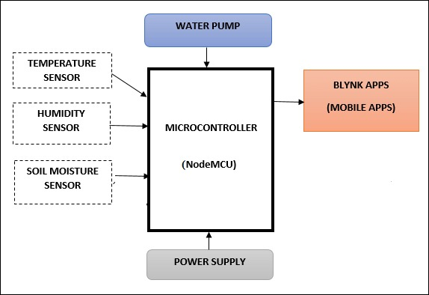
Fig 3.2.1 Block Diagram

IoT sensors (soil moisture, temperature, humidity, light) collect real-time environmental data from the field. The microcontroller processes the sensor data and sends it to the cloud platform via a wireless communication module. The cloud platform analyzes the data to generate insights on crop health, irrigation needs, and fertilization schedules.
Farmers access the data through a mobile app or web interface, viewing real-time conditions and receiving alerts. Based on the analysis, automated systems (e.g., irrigation) are triggered to optimize resource use.The system provides continuous monitoring and alerts for better decision-making, ensuring sustainable farming practices.

CHAPTER 4
SYSTEM SPECIFICATION

Chapter 4
System Specifications
4.1 Hardware Details
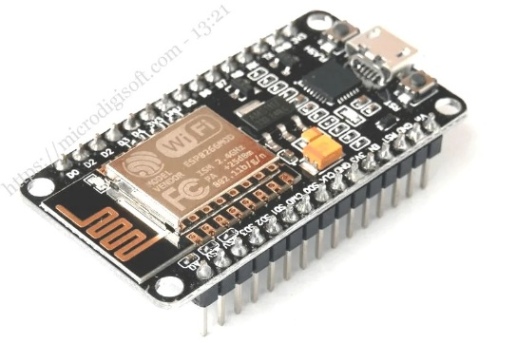
Fig 4.1.1 Node MCU ESP8266
The NodeMCU ESP8266 is a low-cost, Wi-Fi-enabled microcontroller based on the ESP8266 chip. It allows easy integration with IoT projects for real-time data collection and transmission. With built-in Wi-Fi, it can connect to the internet, making it ideal for applications like smart agriculture. NodeMCU is programmable using the Arduino IDE, supports several GPIO pins for sensors and actuators, and is energy-efficient, compact, and affordable for IoT projects.

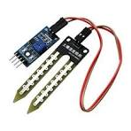
Fig 4.1.2 Soil moisturizer sensor
A Soil Moisture Sensor measures the water content in soil to help optimize irrigation. It works by detecting the soil's resistance or capacitance, which changes with moisture levels. The sensor sends data to a microcontroller (like NodeMCU), enabling automated watering systems and efficient water usage in agriculture and gardening.

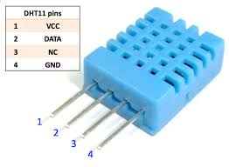

Fig 4.1.3 DHT Module

The DHT11 Sensor is a low-cost sensor used to measure temperature and humidity. It provides digital output, making it easy to interface with microcontrollers like Arduino or NodeMCU. The sensor offers a temperature range of 0-50°C and humidity range of 20-80% with relatively low accuracy. It's commonly used in weather stations, environmental monitoring, and IoT applications.

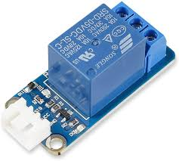
Fig 4.1.4 Relay Module
A Relay Module is an electrical switch that allows a low-voltage microcontroller (like Arduino or NodeMCU) to control high-voltage devices (like motors, lights, or pumps). It works by using an electromagnet to open or close the circuit, enabling the microcontroller to turn devices on or off. Relay modules are commonly used in automation, home control, and IoT projects.

Top of Form

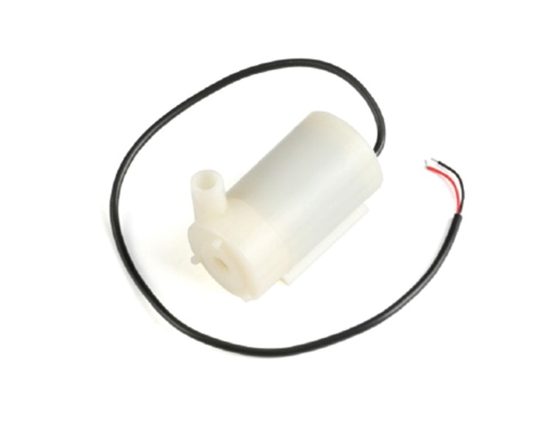

Fig 4.1.5 Water Pump Module

It typically includes a small DC water pump and a driver circuit (relay, transistor, or MOSFET) that allows it to be controlled by a microcontroller like an Arduino or ESP32. The pump operates by receiving a signal from the controller, which activates the driver to supply power to the pump. This setup is ideal for applications where automatic water flow based on sensor input (like soil moisture or water level) is required.

CHAPTER 5
CIRCUIT DIAGRAM

Chapter 5
5.1 Circuit Diagram
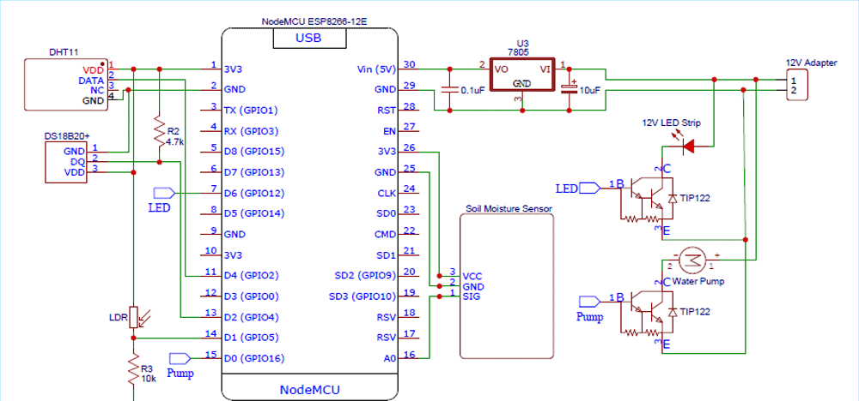
Fig 5.1 Circuit Diagram
This Smart Agriculture System is an IoT-based solution designed to automate essential tasks in farming or gardening by monitoring environmental conditions and controlling irrigation and lighting. At the core of the system is the NodeMCU ESP8266-12E, a powerful microcontroller with built-in Wi-Fi capability, allowing the system to connect to the internet for remote monitoring or control.
The system is powered by a 12V DC adapter, which supplies power to both high-power components like the 12V water pump and LED strip, and low-voltage electronics like the NodeMCU and sensors. A 7805 voltage regulator converts the 12V input down to a stable 5V supply, suitable for the microcontroller and sensor modules. Capacitors placed before and after the regulator help filter voltage fluctuations and provide smooth operation.
To gather environmental data, the system uses several sensors:
- The DHT11 sensor measures temperature and humidity in the air, helping monitor general weather conditions.
- The DS18B20 digital temperature sensor provides accurate readings of soil or water temperature. A 4.7kΩ pull-up resistor is used to ensure stable communication on the 1-Wire data line.
- A soil moisture sensor detects how wet or dry the soil is. It outputs an analog or digital signal to indicate the moisture level, enabling automatic irrigation decisions.
- An LDR (Light Dependent Resistor) is used to sense the intensity of ambient light. It forms a voltage divider circuit with a 10kΩ resistor and sends analog data to the NodeMCU.
Based on input from these sensors, the NodeMCU makes decisions and activates output devices. The 12V water pump is used to irrigate the plants when the soil moisture level drops below a threshold. Likewise, the LED strip simulates sunlight and is turned on when the LDR detects insufficient ambient light.
Both the pump and LED strip are controlled using TIP122 NPN transistors, which act as electronic switches. The NodeMCU sends a control signal (HIGH/LOW) to the base of each transistor through a current-limiting resistor. When the transistor is activated, it allows current to flow from the 12V supply to the pump or LED strip through the collector-emitter path, turning them ON.
This intelligent system automates key agricultural operations, reducing the need for manual monitoring and improving efficiency. Its Wi-Fi capability allows real-time data to be uploaded to cloud platforms or sent to a smartphone app, enabling farmers or gardeners to keep track of conditions and control devices remotely. This makes the system ideal for modern smart farming practices where resource conservation and precision are critical.

CHAPTER 6
ALGORITHM

Chapter 6
Algorithm

1. Initialization:
- Include the Servo library for motor control.
- Define pins for light sensors and servo motor.
- Create a Servo object for controlling the motor.
2. Setup Function:
- Initialize serial communication for debugging (optional).
- Set sensor pins as inputs and attach the servo motor to its pin.
- Calibrate the servo motor to its initial position (usually pointing east).
3.Loop Function:
- Continuously read the intensity of light from two sensors.
- Calculate the deviation between the two sensor readings to determine the sun's position.
- Adjust the solar panels' position based on the deviation by controlling the servo motor.
- Add a delay to the loop to prevent rapid movements.
4. Read Light Intensity Function:
- Read the analog values from the light sensors and return the intensity.

5. Adjust Panels Function:
- Calculate the new angle based on the current angle of the servo motor and the desired adjustment.
- Move the servo motor to the new angle to adjust the solar panels' position.

### Notes:
- Adjust the angles and sensitivity values according to your setup and requirements.
- Test the system in different lighting conditions to ensure proper functionality.
- Ensure the mechanical setup is sturdy and well-aligned for accurate tracking.
- Consider adding additional features such as sleep modes to conserve power when sunlight is low.

CHAPTER 7
RESULT

Chapter 7
Result
- Final model of IOT Based Smart Agriculture system:

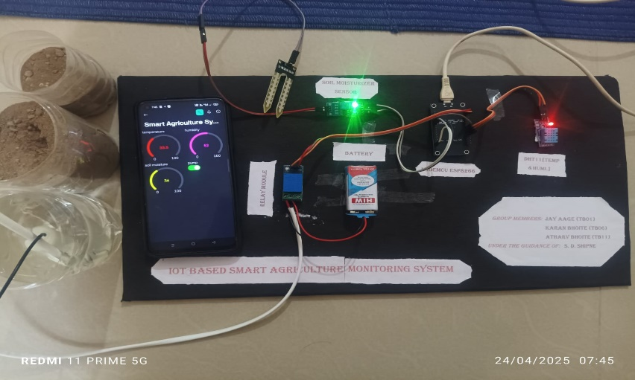
Fig.7.1: Final model of IOT Based Smart Agriculture system
This is an IoT-based Smart Agriculture Monitoring System model. It uses sensors like a soil moisture sensor, DHT11 sensor (for temperature and humidity), and a water level sensor to collect environmental data. The data is processed via a microcontroller and displayed in real-time on a mobile app interface. This system helps farmers monitor field conditions remotely and efficiently manage irrigation and crop health.

- Notification by Blynk App :
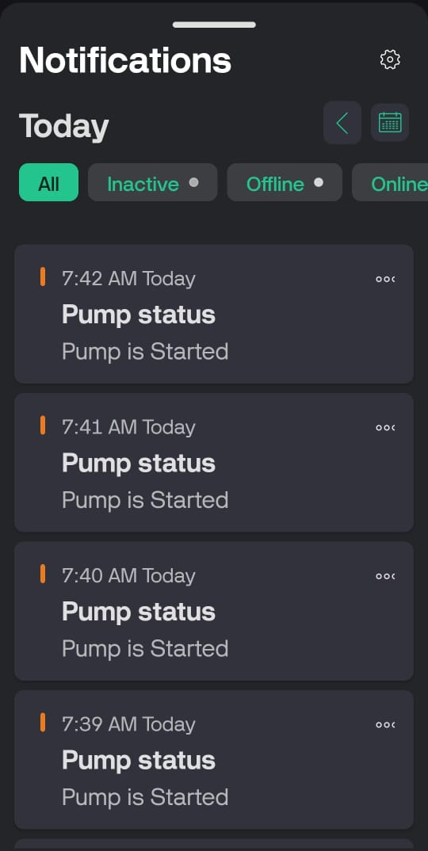
Fig 7.2: Notification by Blynk App :
This Blynk app notification screen shows real-time updates from the Smart IoT-Based Agriculture Monitoring System. It displays repeated alerts that the pump has started at different times (7:39 AM to 7:42 AM). These notifications likely indicate that the system has detected low soil moisture and has automatically triggered the irrigation pump, demonstrating the automated response feature of the smart farming setup.

- Result of Smart IOT based Agriculture Syatem:
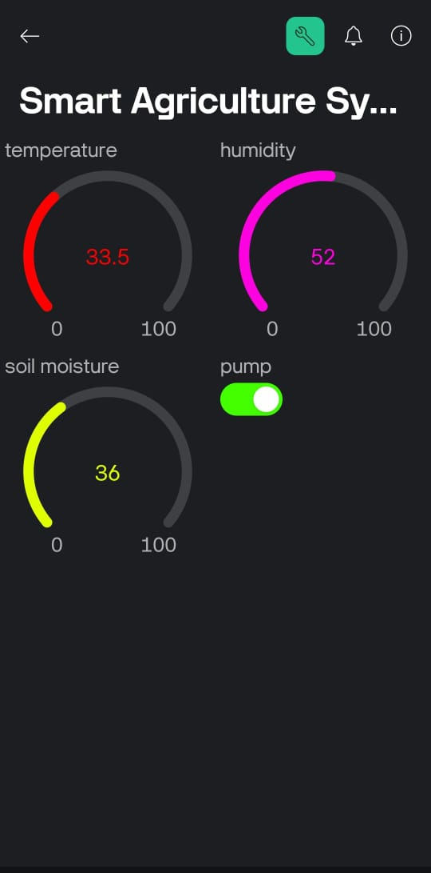
Fig.7.3: Condition of Soil with Blynk App
Image shows the Blynk app interface for a Smart Agriculture System, displaying real-time sensor data. It indicates a temperature of 33.5°C, humidity at 52%, and soil moisture at 36%. The pump switch is turned on, likely due to the soil moisture being below a defined threshold.

CHAPTER 8
ADVANTAGES

Chapter 8
Advantages

- Resource Optimization: Reduces water and fertilizer waste.
- Increased Yield: Enhances crop productivity with real-time data.
- Sustainability: Promotes eco-friendly farming practices.
- Remote Monitoring: Farmers can track conditions from anywhere.
- Automation: Automates irrigation and other systems.
- Data-Driven Decisions: Provides actionable insights for better crop management.
- Cost Efficiency: Lowers operational costs through optimized resource use.
- Scalability: Adaptable to various crops and farm sizes.

CHAPTER 9
CONCLUSION

Chapter 9
Conclusion

The IoT-based Smart Agriculture Monitoring System provides a significant advancement in modern farming practices by integrating real-time data collection, automation, and data-driven insights. By optimizing resource usage, improving crop yield, and promoting sustainable farming, the system helps farmers make informed decisions that enhance productivity and reduce waste. The ability to monitor environmental factors remotely and automate processes like irrigation and fertilization ensures greater efficiency and cost savings. Ultimately, this system holds great potential in transforming agriculture into a more efficient, sustainable, and scalable industry, contributing to global food security and environmental conservation.

.

References

- IEEE Xplore (2025) : https://ieeexplore.ieee.org/document/8081906
- Nevon Project (2025) : https://nevonprojects.com/iot-based-smart-agriculture-monitoring-system-project/
- Faststreamtech (2025) : https://www.faststreamtech.com/solutions/smart-agriculture/
- Easternpeak (2025): https://easternpeak.com/blog/iot-in-agriculture-technology-use-cases-for-smart-farming-and-challenges-to-consider/
- Research gate (2025) : https://www.researchgate.net/publication/371071895_IOT_Based_Smart_Agriculture_Monitoring_System

